5 best apps to find gaming friends instantly
https://unblnd.com/blog/5-best-apps-to-find-gaming-friends-instantly

1. WeGamers
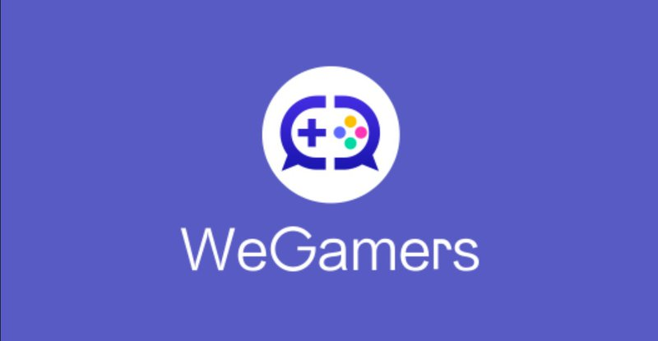 App to find gaming friends - WeGamers
WeGamers is a social community app that made for gamers by gamers! In this community, you can learn tips and tricks from experienced game streamers or other players. WeGamers features different bundles to boost the gaming experience for gamers around the world, and users can use the Points to redeem exclusive bundles on WeGamers. Are you wondering how to get these Points? You can collect them by completing an activity created by WeGamers. It is also possible to get the latest game information and exclusive game giveaways, and immerse yourself in fascinating articles and posts written by other gamers! You can download it on Playstore and Appstore

2. UNBLND
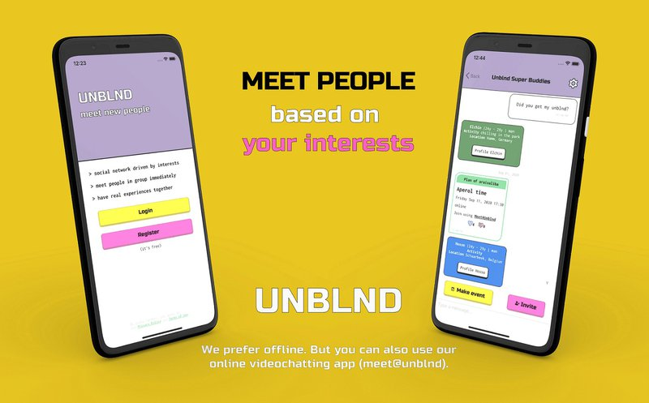 App to find gaming friends - UNBLND
UNBLND is a recently launched social network app that connects strangers and turns them into a group of friends. This app instantly puts you in touch with like-minded people by getting you into relevant groups, such as Gaming. Sounds fun, right? The recent update gives the possibility to create breakouts that means you can create a new group based on your interests inside the existing group. Ex: within the “Online Gaming” group, you can create your own more specific group for any interest or games such as Among Us. You can download it from Apple Store or Google Play. Are you wondering how you can join the Gaming group on UNBLND?
You can simply scan the QR code below. If you already have an account, you will be redirected to this Gaming group right away.
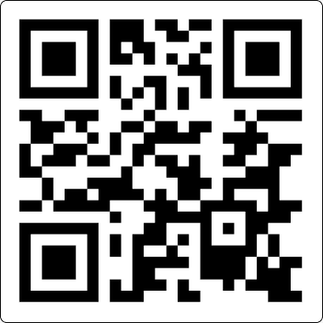
You can just point the camera of most mobile devices!
Or use unblnd.com/nvt/grp/vEAA45
You can also use free video chat to communicate with group members. That is possible with meet@unblnd. You can download it on your phone or create a meeting directly from your computer.

3. GamerLink
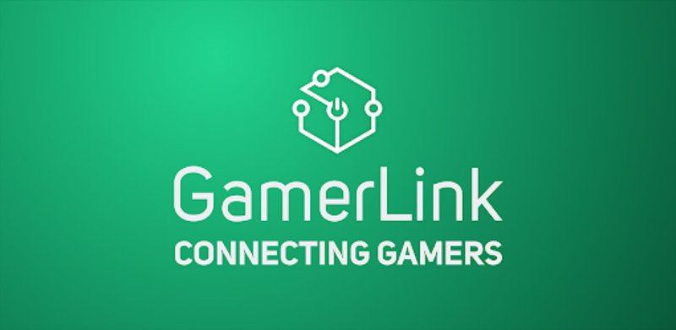 App to find gaming friend - Gamerlink
Gamerlink is a gaming social network app that helps gamers connects, find and interact with other like-minded gamers and friends for a better online multiplayer experience. This goal is achieved by connecting gamers of similar skill, playstyle, demographics and much more. You can create your own personalized profile to consolidate your online gaming identity. If you want to find the perfect teammates, you can download it on the App Store and Playstore.

4. GameTree
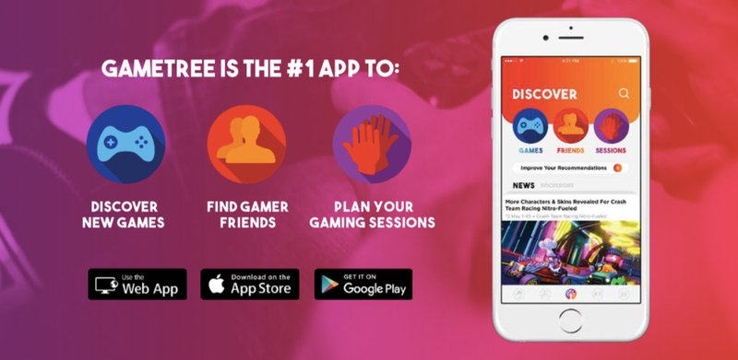 App to find gaming friends - Game Tree
GameTree is a new friend-finding app for gamers that helps you find the friends and games you will love most in an increasingly crowded and lonely world. It can help you determine how well your personalities will mesh, and you can search for friends based on personality type. For that, the app will require you to take a values quiz so that it can recommend people with similar thinking patterns. This app also allows you to create sessions where you announce to other players which game you are currently playing, how long you will be playing it, and the number of players still needed for your team. you can download it on PlayStore and AppStore for free.

5. PLINK
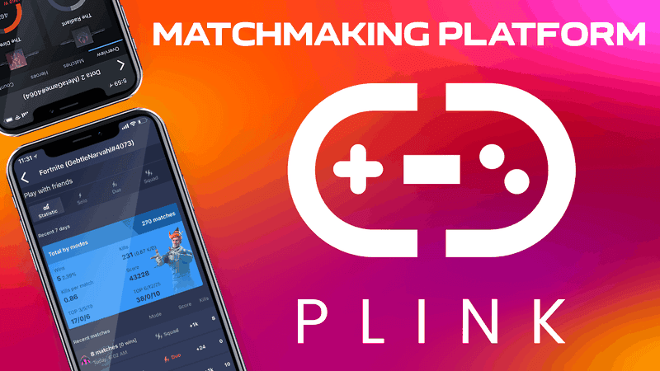 App to find gaming friends - PLINK
Plink is a revolutionary app for gamers. You can forget about playing alone because their search system will analyze your game skills and find the best teammate for you. Here you can build your own squad with hundreds of gamers! and follow famous streamers and stream online! They also have a swipe function. You can use swipes to like or pass on players. If someone likes you back, it’s a match! They also will provide you with high-quality voice calls, group chats, private messages. You can download PLINK on Play Store and App Store.

Game Changer

TAUNTON & BRIDGWATER

Main information
Type of service: Online services, Play and leisure, Social groups
Website: http://www.ANVG.co.uk
We provide 3hr Video Gaming/friendship sessions once a week in Taunton (Monday 1-4pm) and Bridgwater (Thursdays 1-4pm ). Using Video gaming on the latest systems to bring people back into their communities after lockdown. Using a no-pressure environment we are there to help facilitate fun, friendship and practical advice when needed. We also cover online/internet safety (especially around social media). The aim is to help people with learning disabilities get the most out of life by using the latest technology to improve their life skills and independence safely.
We are based in Somerset working from Taunton Library and the Hub Charity, Angel place, Bridgwater. We accept members from anywhere as long as you can travel to us - realistically Somerset/Devon/North Somerset.
Eligibility
Age: From age 18 to 100
Aimed at: Adult
Gender: All genders

The Association for Neurodiversity in Video Games (ANVG) exists to enable gaming companies to better understand, engage and embrace neurodiversity in the production and content of video games. We want to change culture, so people’s differences are seen, accepted and celebrated.

