Suicide Prevention

Across England as a whole, one person dies every two hours as a result of suicide. In 2015, there were 5,199 registered suicides in England and Wales. The effect of a death resulting from suicide on family and friends is devastating. Others who knew the person through work or education, or who were involved in providing support and care will feel the impact profoundly.

Not all suicides are inevitable. Around a quarter of all deaths are people in contact with specialist mental health services ([University of Manchester](http://www.bbmh.manchester.ac.uk/cmhr/research/centreforsuicideprevention/nci/)). A much higher proportion may have had contact with their GP or other health service. Suicide can be the end point of a complex history of risk factors and distressing events; and action to prevent suicide has to address this. Find the [National suicide prevention strategy on the GOV.UK web site](https://www.gov.uk/government/publications/suicide-prevention-strategy-for-england) or download the local [**Somerset strategy**](http://www.somersetintelligence.org.uk/files/Somerset%20Suicide%20Prevention%20Strategy%202013-2016%20v3.pdf), more details can be found below.

This webpage provides information on suicide rates and trends for Somerset in comparison with the national picture. These are, by their nature, retrospective by at least two years. Please note that in 2015 the trend report has been supplemented by information drawn from a newly established case audit system, which will provide a more real-time view on themes, issues and action.

In this section we have used two sources of data: the Public Health Outcome Framework (PHOF) and the Health and Social Care Information Centre (HSCIC). At the time of writing, data are available up to 2013 for PHOF and up to 2012 for HSCIC. It is important to understand suicide statistics in respect of the definition, timeliness, reliability and the different sources. For an explanation of suicide statistics please click [here](http://www.somersetintelligence.org.uk/).

National Context

In February 2016, the Office for National Statistics published national and regional [annual trends in suicide statistics](http://www.ons.gov.uk/peoplepopulationandcommunity/birthsdeathsandmarriages/deaths/bulletins/suicidesintheunitedkingdom/2014registrations) from 1981 to 2014.

* The latest year saw the highest number of male suicides in this period, and the highest age-standardised rates for all persons since 2004.
* The highest suicide rate in the UK in 2014 was for men aged 45-49 at 26.5 per 100,000 population.
* In 2014, the South West was the region with the highest suicide rates amongst women in the UK
* In 2014, suicide was the leading cause of death for people aged 20 to 34.
* After declining throughout the 1980s and 1990s, suicide numbers amongst men in their 50s and 60s have increased in recent years.

Key Facts for Somerset

* There have been 485 suicides recorded in Somerset between 2005 and 2014, an average of almost fifty a year.
* In the five-year period 2010-14, suicide rates in Somerset amongst men aged 65 or older were significantly higher than the national average.
* The suicide and undetermined death rate for Somerset for the period 2012-14 was 9.4 per 100,000, statistically similar to the national average (8.9) and the South West figure of 10.1. The trend over the past twenty years is fairly static in Somerset and regionally, while there has been a slow decline in England. However, in the last decade, the trend is more stable generally, with no significant difference between Somerset and the regional and national averages (see Figure 1).
* Rates of mortality from suicide and undetermined death for both females and males are highest for those aged 35 to 64 (see Figure 2).
* Around 70% of deaths are male, reflecting the pattern nationally.
* For 2010-2012 as a whole, the rate of suicide or injury undetermined in Somerset was 7.3 per 100,000 persons aged 15-34, which compares with an England average of 7.8 per 100,000. This difference is not statistically significant.
* As in England generally, the most common method of death was hanging and the most common place of death is at home (60% in Somerset).
* The Somerset Case Audit for 2014 suggests that in Somerset around 50% of all deaths are people in contact with specialist mental health services, compared with 30% nationally. This indicates opportunities for suicide prevention within mental health services and for ensuring support for people living in recovery. It also serves as a reminder that many people who go on to complete suicide have no previous history of mental illness.
* There is a strong association between suicide rates and levels of deprivation. The rate for suicide and undetermined death for residents living in the 20% most deprived areas in Somerset is significantly higher than for the county as a whole (see Figure 3).
* There are no statistically significant variations between the five districts.
* The reported suicide rate can vary, depending on the years reported or the age groups included. This does not mean the actual numbers have changed, but that a different method of calculation has been used.
* [Preventing Suicide in Somerset - Audit Report 2015](http://www.somersetintelligence.org.uk/files/Preventing%20Suicide%20in%20Somerset%20Audit%20Report%202015.pdf)  
  Detailed summary of facts, figures and strategies on suicides in Somerset

Figure 1 Rolling 3-Year Trends in Rates of Mortality from suicide and undetermined death, 2003-05 to 2010-2012

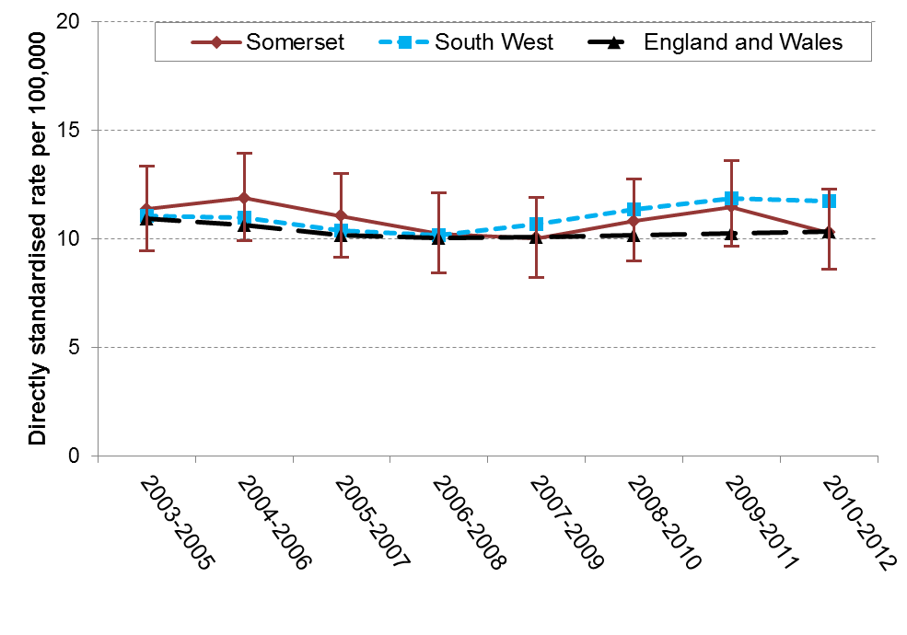

Figure 2 Rates of Mortality from suicide and undetermined death in Somerset 2010-12 by Sex (with confidence intervals)

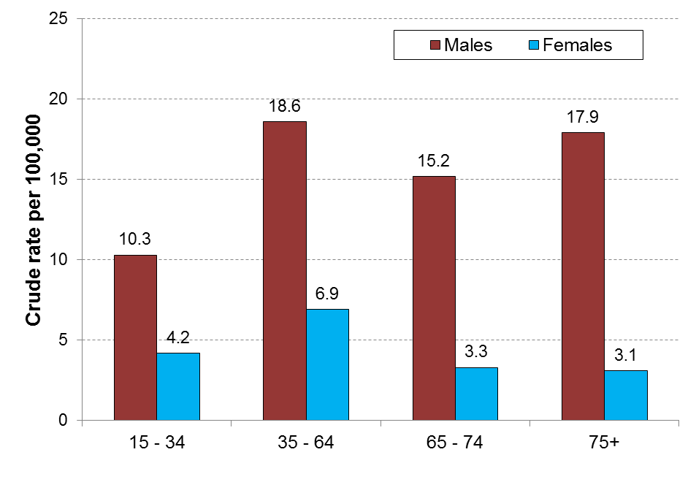

Figure 3 Suicides and undetermined death in Somerset, 2006-13, by Deprivation quintile

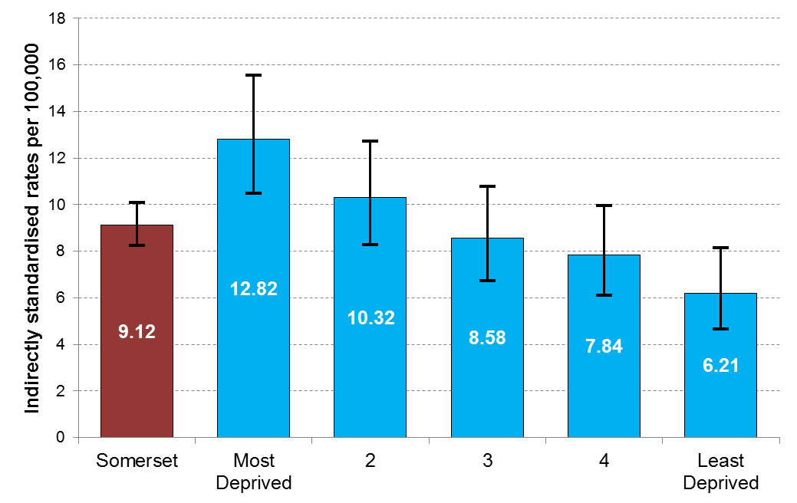

For more data, see Public Health England's [Suicide Prevention Profiles](http://fingertips.phe.org.uk/profile-group/mental-health/profile/suicide) which are updated frequently.

Strategies for Suicide Prevention

National strategy:

The health strategies of many countries include targets to reduce suicide rates. In England, [Preventing Suicide in England](https://www.gov.uk/government/publications/suicide-prevention-strategy-for-england) – a cross governmental strategy to save lives - was launched in 2012. This is the second national suicide prevention strategy and it sets out six key priority action areas to be progressed both at national and local level:

* Reduce risk of suicide in high risk groups
* Tailor approaches to mental health support in specific groups
* Reduce access to the means of suicide
* Provide information and support to individuals bereaved by suicide
* Support the media to report appropriately on incidents of suicide
* Implement research, data collection and monitoring

Local strategy:

Local responsibility for coordinating and implementing work on suicide prevention became, from April 2013, an integral part of local authorities’ new responsibilities for leading on local public health and health improvement. Included in these responsibilities is the establishment of a local suicide prevention partnership, the implementation of a process for local suicide audit and the delivery of local action to prevent and reduce suicide.

The Somerset Suicide Prevention Advisory Group is the multi-agency forum which leads this work locally. The Suicide Prevention Advisory Group is responsible for the delivery of the Somerset Suicide Prevention Strategy and Action Plan, which focusses on the local areas for action (see below).

* [Somerset Suicide Prevention Strategy 2013-16](http://www.somersetintelligence.org.uk/files/Somerset%20Suicide%20Prevention%20Strategy%202013-2016%20v3.pdf)  
  The current strategy produced by the Somerset Suicide Prevention Advisory Group

The overall vision of this Strategy is:

1. To contribute towards the continued reduction in the death rate from suicide
2. To provide better support for those bereaved or affected by suicide.

 It works to the themes of:

* **prevention** of suicidal thoughts – promotion of wellbeing and reducing risk factors that can lead to suicidal thoughts
* **provision** of appropriate and effective support and treatment – availability of effective support, treatment and antidotes to enable people to continue with their lives
* **protection** to help keep people safe – related to influences such as the media, culture and reduced availability and lethality of suicide methods

The six key priority goals are aligned with the national ones listed above, and the Strategy will work in partnership with the Public Mental Health action plan as part of the [Somerset Mental Health and Wellbeing Strategy](http://www.somersetintelligence.org.uk/files/Positive%20Mental%20Health%20Strategy%20for%20Somerset%20Oct%202014.pdf).

**Putting Men into Mental Health**

In October 2015, a conference was organised by Somerset County Council Public Health and the Men's Health Forum. The [Conference Report](https://www.menshealthforum.org.uk/sites/default/files/pdf/somerset_v4_lr.pdf) includes key issues (such as male suicides) as well as possible solutions. A Men’s Mental Health Interest group has since been formed and further actions are being developed.

Somerset Case Audit Report 2014

The case audit process looks at deaths within the year in which they have occurred, for which the most probable cause is suicide. The first report analysed 41 deaths during the 2014 calendar year.

The findings of the case audit support local on-going action in terms of a focus on:-

* Men's mental health
* Self-harm support and prevention
* Contact with mental health services
* Preventing Railway deaths
* On-going support training and resources for GPs

Understanding suicide statistics

Official suicide statistics in the UK are based upon coroners’ verdicts. In the case of a suspected suicide an inquest will be held. For a death to be recorded as a suicide intention to die by suicide must be proven. If not proven, such deaths are most likely to receive open verdicts and be classified in national statistics as deaths of undetermined intent.

Research indicates that over three-quarters of deaths given open verdicts by coroners are likely to be suicides. Therefore, in an attempt to provide a more accurate estimate of the true levels of suicide, the data reported here presents figures for both suicide and undetermined deaths. A significant number of deaths receive death by misadventure, accidental death or, increasingly, narrative verdicts, and so will not appear in official suicide statistics. There is growing evidence that differences between coroners in their use of narrative verdicts across the country is making comparison of suicide statistics between areas less reliable.

Timeliness:

The coroner’s verdict may be given some time after the time of death. For this reason, the analysis of suicide trends is always retrospective by a period of two years. The case audit system which is being implemented locally will provide more timely information on deaths, prior to the coroner’s verdict, which are likely to be the consequence of a suicide.

Reliability:

Due to the relatively low number of deaths by suicide within a local area, numbers can fluctuate. For this reason it is considered good practice to undertake analysis of trends in three year periods. It is important to look at the time period when comparing data, as an analysis of a different year grouping will produce slightly different rates

.

Understanding published suicide rates:

In January 2012 a new indicator measuring suicide rates was introduced in the [Public Health Outcomes Framework](http://www.phoutcomes.info/) (PHOF 4.10). This indicator reports age-standardised mortality rate from suicide and injury of undetermined intent per 100,000 population. This indicator includes deaths by suicides for people of all ages but only undetermined death for people **aged 15+** in line with the ONS definition.  
Historically the NHS/Health and Social Care Information Centre [(HSCIC](http://www.hscic.gov.uk/searchcatalogue)) indicator portal has published data on suicides and undetermined death for people of all ages and for those aged 15+. However, from 2009-2011 onwards the all-ages indicator has been suppressed and is no longer published.

Many people who have had suicidal thoughts say they were so overwhelmed by negative feelings they felt they had no other option. However, with support and treatment they were able to allow the negative feelings to pass.  For confidential help and assistance, please [click here](http://www.nhs.uk/Conditions/Suicide/Pages/Getting-help.aspx).  Alternatively, email  (24 hours)  [jo@samaritans.org](mailto:jo@samaritans.org) or ring Samaritans (24 hours) 08457 90 90 90.

**Further Information:**

* For information on training, courses and publications relating to suicide prevention, please see the [Connecting with People website](http://www.connectingwithpeople.org/healthcare-front).
* For information on Self-Harm, please visit our [Self-Harm webpage](http://www.somersetintelligence.org.uk/self-harm.html)
* For Public Health England profile indicators related to suicides, please go to the [PHE Fingertips website](http://fingertips.phe.org.uk/search/suicide#page/4/gid/1/pat/6/par/E12000009/ati/102/are/E10000027/iid/91430/age/27/sex/1).
* [Preventing Suicide in Somerset Audit Report - 2014](http://www.somersetintelligence.org.uk/files/Preventing%20Suicide%20in%20Somerset%20Audit%20Report%202014.pdf)