Referral Procedure

Standard Operating Procedure

Mixed Homelessness Pathway
Author / Owner name | David Kelso | Creation Date | 13/03/18
Approval Date | 25/05/18
Review Date | 14/05/19 | Implementation date | 04/06/18
Acronyms
ISAT | Interim and Supported Accommodation Team (BCC staff)
HSR | Housing Support Register (BCC staff)
BCC | Bristol City Council
HPT | Homeless Prevention Team (BCC staff)
VNF | Void Notification Form
OMG | Operation Management Group (Made of pathway partners)

Scope
This standard operating procedure (SOP) sets out the client referral process within the mixed homeless pathway from point of entry to exit from homeless interventions.
This aims to ensure that clients referred into the pathway are managed through an efficient and inclusive process that supports them to move quickly as possibly, regardless of which level they came into, while ensuring the process provides clients with the best chance of sustaining positive changes in their lives.

Level 1 Referrals

Background
People at risk of homelessness or currently homeless present at BCC service points, e.g. 100 Temple Street. BCC assess suitability based on:
- Risk
- Needs
Suitable candidates are added to HSR and flagged up to pathway accommodation providers

Process
- Vacant room; when a room becomes vacant, accommodation provider completes a Void notification form which is returned to ISAT email address:
Accommodation.services@bristol.gov.uk

- ISAT nominates top priority client for service, and notifies accommodation provider via email
- Accommodation provider logs in to the HSR system and checks client referral
- Assess clients suitability for support based on:
  - Risk (to themselves and other clients within the service)
  - Clients needs (can the service provide support to move the client forward)
- Accommodation provider Informs ISAT of decision accept or reject
- Client Accepted :ISAT arrange face to face meeting between client and accommodation provider
- Accommodation provider carries out face to face client assessment based upon:
  - Risk (to themselves and other clients within the service)
  - Clients needs (can the service provide support to move the client forward)
- Client accepted by service. VNF completed by pathway accommodation provider, indicating date of move. Forms returned to HSR email address:
Accommodation.services@bristol.gov.uk
- ISAT update HSR with address and removes client from priority list
- Client Rejected by accommodation provider; ISAT nominate next priority client
- Accommodation provider completes room checks and prepares a welcome pack ready for client to move in.
Process Map See appendix 1
Void Notification form: See appendix 2

Level 1 Outreach Access beds

Background
Outreach Access Beds are designed for clients who are rough sleeping and have been engaged by the St Mungo’s outreach team.
To access the outreach access beds clients are nominated by BCC directly to the outreach team for service assessment.

Process
- BCC HPT contact outreach team at St Mungo’s to nominate client
- Outreach team assess client suitability based on:
  - Risk (to themselves and other clients within the service)
  - Clients needs (can the service provide support to move the client forward)

- Accommodation provider Informs ISAT of decision to accept or reject
- ISAT arrange face to face meeting between client and accommodation provider
- Accommodation provider carries out face to face client assessment based upon:
  - Risk (to themselves and other clients within the service)
  - Clients needs (can the service provide support to move the client forward)
- Client accepted by service. VNF completed by pathway accommodation provider, indicating date of move. Forms returned to HSR email address:
accommdationservices@bristol.gov.uk
- Accommodation provider completes room checks and prepares a welcome pack ready for client to move in.

- ISAT update HSR with address and remove client from priority list
- Client Rejected by accommodation provider; ISAT nominate next priority client
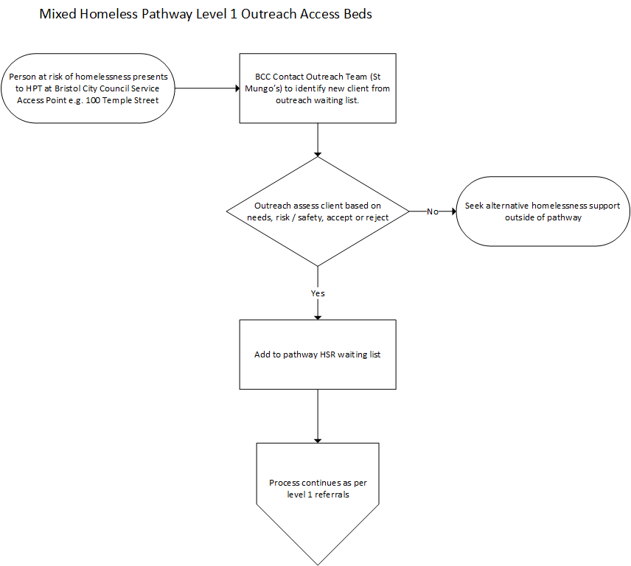

Pathway Move-on

Background
This process covers how clients move between levels 2 – 4 within the pathway and the preparation stages for moving out of the homeless mixed accommodation pathway.

The homeless mixed accommodation move-on values statement includes detailed information of what accommodation providers will offer clients to support move-on; how pathway partners will work together to provide a smooth handover between partners; and what external agencies will be engaged to support clients moving out of the pathway.

To support move-on Pathway Partners will
- Ensure move on transitions are carried out efficiently with minimal barriers

- Provide a flexible process which identifies and meets the needs of the client, creating a positive experience for the individual

- Link clients with local agencies which can support move-ons out of the homeless pathways

- Support partner agencies with move-ons by providing consistent and clear information utilising the HSR system

Suitable candidates for moving on, or out of the pathway will be identified at OMG. The referring partner will ensure that:

- The HSR system is up to date prior to nominations.

- OMG on any delays to move-ons, indicating any delays which will adversely effect voids times

- Move in to accommodation are planned with OMG.

Process
- Client move-on is agreed by accommodation provider or client notifies current accommodation provider of intention to move-on.

- Current accommodation provider updates HSR prior to move indicating move-on date and address
- Handover; start 2 week handover process between current accommodation provider and recipient accommodation provider. Ensure that any tenancy termination / license agreement paperwork is completed and forward to partners prior to move out.

  - Week 1;
- Face to face meeting between client and recipient accommodation provider
- Assessment of on-going client needs
- Date and time of move agreed

  - Week 2;
- Second face to face client and support worker meeting
- Complete accommodation sign up paper work
- Pack belongings

  - Day before move:

- Book taxi or person with van

  - Day of move
- Clear, clean and refurnish room
- Book / complete electric check (this can only be carried out when the room is vacant)
- Create welcome pack for next client

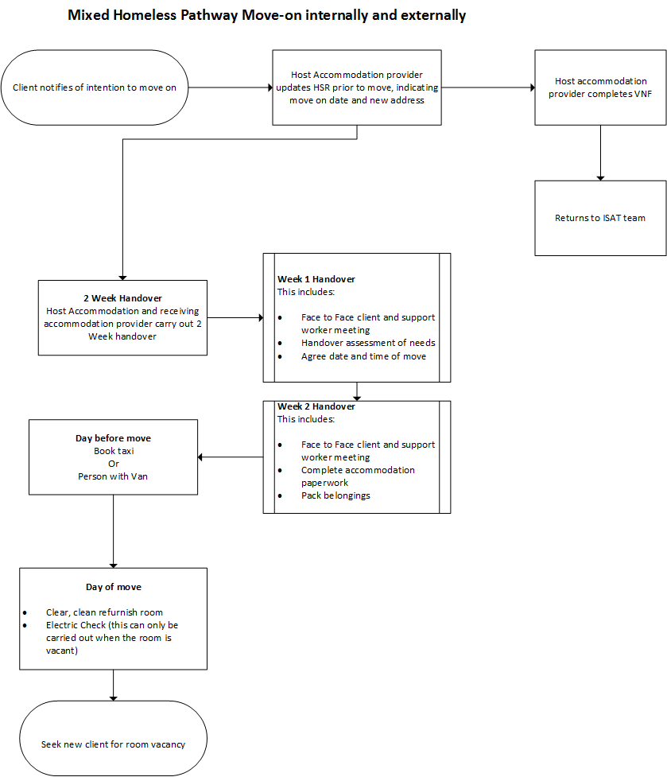

Cross Pathway moves

Client’s can be nominated to move between pathways, e.g. from pathway 1 (male) to Pathway 2 (mixed). This can only be carried out via the ISAT team and with their agreement.
Prior to contacting ISAT planned and emergency moves must be discussed at OMG and raised with potential receiving accommodation provider
Process
- Current accommodation provider contacts ISAT, indicating reasons for move.

- ISAT assess reasons for move and either:

- Reject: Client stays in current service
- Accepts: Move client
- ISAT liaises with pathway contract manager to achieve move.

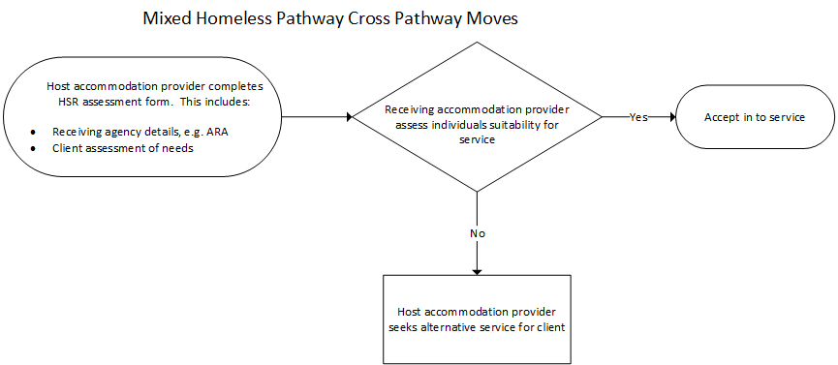

Exit pathway referral to floating support

Background
Clients leaving the pathway can be referred to a local providers of a floating support service. If the client is moving out of the region, the Local Authority within that region will be able to provide details of the floating support service provider.
Note: Clients can exit from the pathway at any level and be referred

Process
- Current accommodation provider completes floating support form, this is returned to the HSR service.
- HSR forwards form to floating support provider.
- Floating support provider contacts client directly.
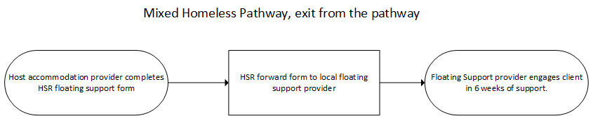

Floating Support Service Offer

The floating support provider in Bristol offers interventions based at clients homes. Clients will need to sign up to a support agreement and can be engaged with in the pathway up 2 weeks prior to moving out. There is no min / max period that resettlement support can be offered but, this will depend upon needs and service demands.
Clients who decide to opt out of initial support offer can be considered at a later date but this will depend upon service demands.
Referrals for this service will be via HSR team who can be contact on:
Accommodation.services@bristol.gov.uk

Appendix 1
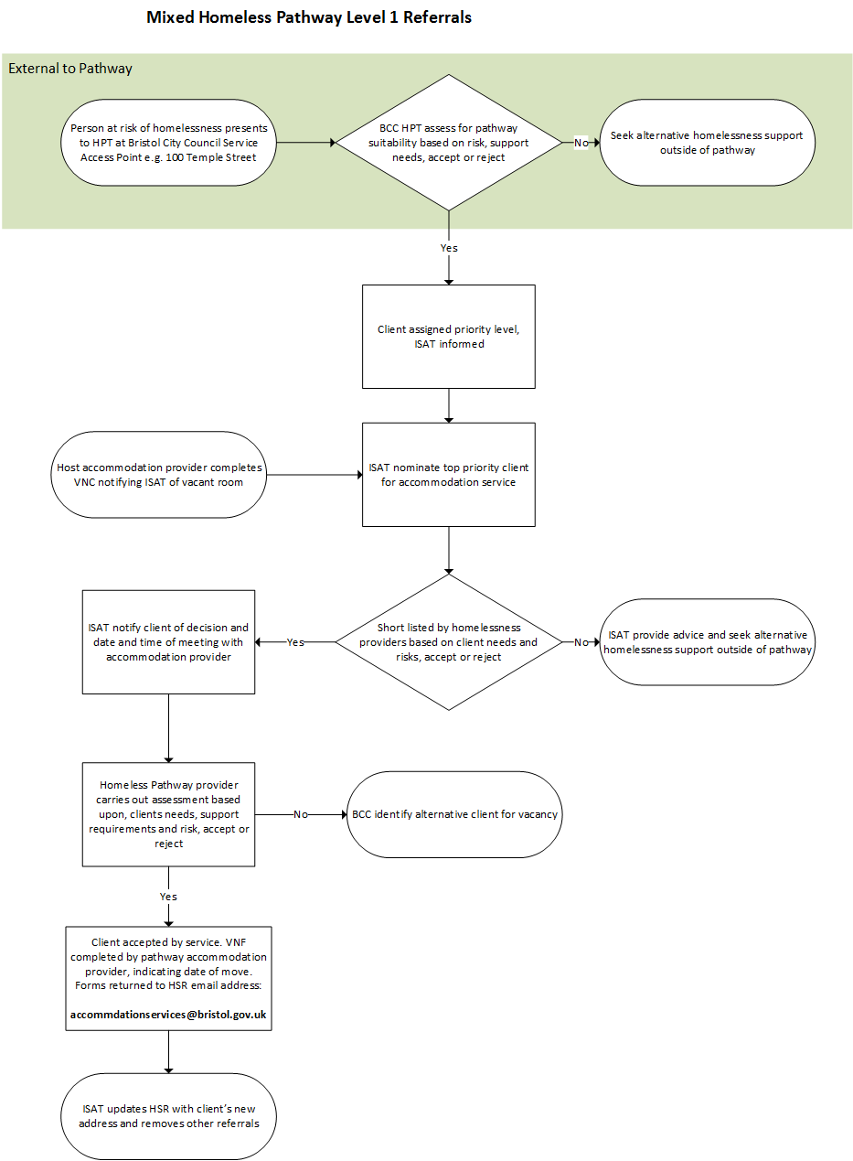

Appendix 2 Void Notification Form

VOID NOTIFICATION FORM

This form must be used by Level 1 High Support Service Providers to inform the Interim and Supported Accommodation Team (I&SAT) of any voids.
Once completed the form should be emailed to: accommodation.services@bristol.gov.uk

Please use a separate form for each void
Part One - About the Void
To be completed by Accommodation Provider
 |  | About the person sending this Void Notice
Q1.1 |  | Name
Q1.2 |  | Name of Service
 | About the Void
Q1.3 | Room/Unit Number
Q1.4 | Name of previous service user
Q1.5 | Date previous service user last occupied room
Q1.6 | Date notice served (if applicable)
Q1.7 | Date notice expired (if applicable)/Date previous service user booked out
Q1.8 | Reason for notice (if applicable) or delay in booking out
Q1.9 | New address of previous service user/s
Q1.10 | Date room available
Q1.11 | Reason for any void delays

Q1.12 Reason for Leaving
Supported Housing (Same Pathway) |  | Abandoned (Unplanned)
Supported Housing (Different Pathway) |  | Custody - Breach of Prior Order (Unplanned)
BCC Tenancy NOT via PMOS (Planned) |  | Custody Current Offence (Unplanned)
BCC Tenancy via PMOS (Planned) |  | Death (Unplanned)
Custody - Hearing/Arrest Warrant for Prior Offence (Planned) |  | Evicted (Unplanned)
Hospital, Care Home or Hospice (Planned) |  | Hospital, Care Home or Hospice (Unplanned)
Substance Misuse Pathway (Planned) |  | Non-HSR Supported Accom (Unplanned)
Non-HSR Substance Misuse Accom (Planned) |  | Other (Unplanned)
Non-HSR Supported Accom (Planned) |  | Psychiatric Hospital (Unplanned)
Other (Planned) |  | Renting Privately (Unplanned)
Psychiatric Hospital (Planned) |  | Staying with Friends or Family (Unplanned)
Renting Privately (Planned)

RSL Tenancy NOT via PMOS (Planned)

RSL Tenancy via PMOS (Planned)

Staying with Friends or Family (Planned)

 | About the nominee requested
Q1.13 | Some services may need to ensure an appropriate balance of gender or other factors when selecting a new client. Please use the space below to detail (together with a brief reason) any such factors you wish to be taken into account by I&SAT when nominating a referral for this vacancy.

Part Two – Nomination by I&SAT
To be completed by I&SAT
Q2.1 | Date VNF received by I&SAT (taken from email)
 | The applicant we are nominating for this void is:
Q2.2
Q2.3 | Date nomination sent
Q2.4 | Previous nominations

Part Three – Interview
To be completed by Service Provider and returned to I&SAT as soon as an interview date has been set.
Q3.1 | What date and time has been set for interviewing the applicant?
Q3.2 | Has the applicant been informed?

Part Four – Outcome
To be completed by Accommodation Provider
Q4.1 | What was the outcome of the nomination/interview for the applicant named at 2.2 above? (delete as applicable) | Accepted/Not Accepted
Q4.2 | Date accepted or not accepted
Q4.3 | If accepted, what was the date of their admission into the service

Q4.4 | If the applicant was NOT accepted please select a reason from the list below:
Client’s risk too high based on HSR info |  |  | Client’s risk too high based on interview
Risk too high from other residents |  |  | Inappropriate referral for service
Needs too low based on HSR info |  |  | Needs too low based on interview
Service ban/cooling off period |  |  | Applicant refused service
Unable to contact applicant |  |  | Did not attend interview/sign up
Shortlisted by another provider |  |  | Inadequate referral/insufficient info
Accepted for other service in the pathway

Q4.5 | Please provide a further explanation of the refusal reason. If due to risk (from client or to client), please detail what would need to change for them to be accepted in the future.

